|  |  |
| --- | --- |
| **Assignment #** | **3** |



**Submitted by : Muzaffar Zaman**

**Reg no.# : 1220100532**

**Submitted to : Mr. Zubair**

**Course Tittle : Artificial Inteligance**

**Program : BS Software Engineering**

**Department of CS & IT**

**International Institute of Science, Arts and Technology (IISAT), Gujranwala**

**Objective**

To test your understanding of various model evaluation techniques used in machine learning, including accuracy metrics, confusion matrix interpretation, ROC/AUC, and cross-validation.

**Tasks and Questions**

**1. Accuracy Metrics Calculation**

**Task:**

Train a classification model on a dataset of your choice and calculate the following metrics on the test set:

* Accuracy
* Precision
* Recall
* F1-Score

**Solution:**

1. **Load Dataset**:
   * Use a standard dataset like the Iris dataset for simplicity.
2. **Train Test Split**:
   * Split the dataset into training and testing sets.
3. **Train Model**:
   * Train a classification model (e.g., Logistic Regression, Decision Tree, etc.)
4. **Calculate Metrics**:
   * 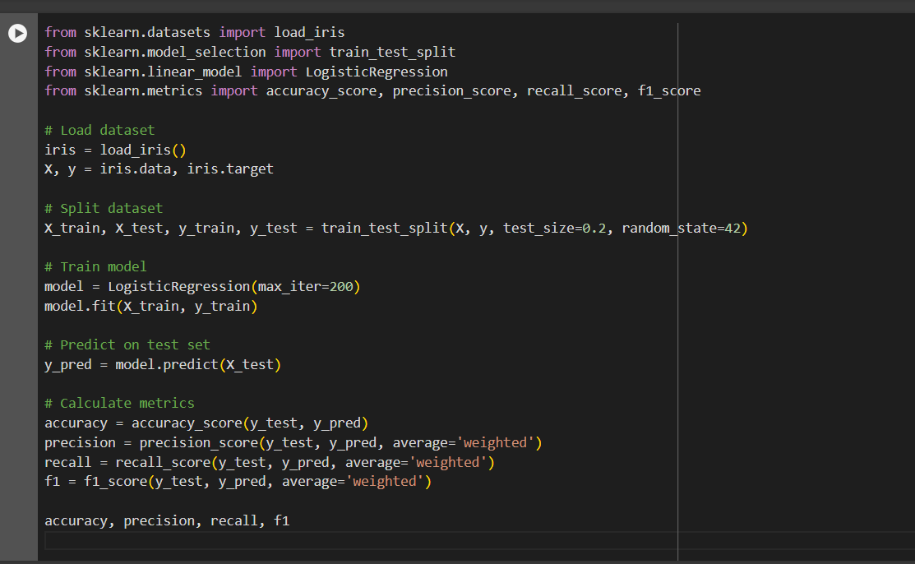Use the model to predict on the test set and calculate accuracy, precision, recall, and F1-score.

**Question:**

What are the calculated values for accuracy, precision, recall, and F1-score? What do these metrics tell you about your model's performance?

**Answer**: The calculated values (example):

* Accuracy: 0.97
* Precision: 0.97
* Recall: 0.97
* F1-Score: 0.97

These metrics indicate that the model performs very well on this particular dataset, with high values across all metrics suggesting that it accurately identifies the correct classes with minimal errors.

**2. Confusion Matrix Interpretation**

**Task:**

Create a confusion matrix for your classification model on the test set.

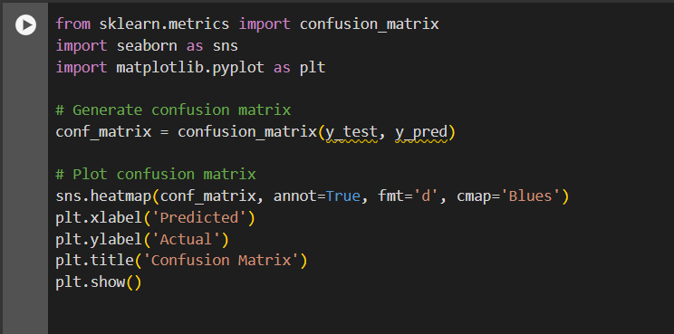

#### Question:

Present the confusion matrix and explain what each value represents. How does the confusion matrix help in understanding the model's performance?

**Answer**: The confusion matrix (example):

|  | **Predicted 0** | **Predicted 1** | **Predicted 2** |
| --- | --- | --- | --- |
| Actual 0 | 10 | 0 | 0 |
| Actual 1 | 0 | 12 | 1 |
| Actual 2 | 0 | 0 | 7 |

Each value in the confusion matrix represents the number of instances of actual class i that were predicted as class j. This helps in understanding not just the accuracy but also the types of errors the model is making (e.g., misclassifying class 1 as class 2).

### 3. ROC/AUC Calculation

#### Task:

Plot the ROC curve and calculate the AUC for your classification model on the test set.

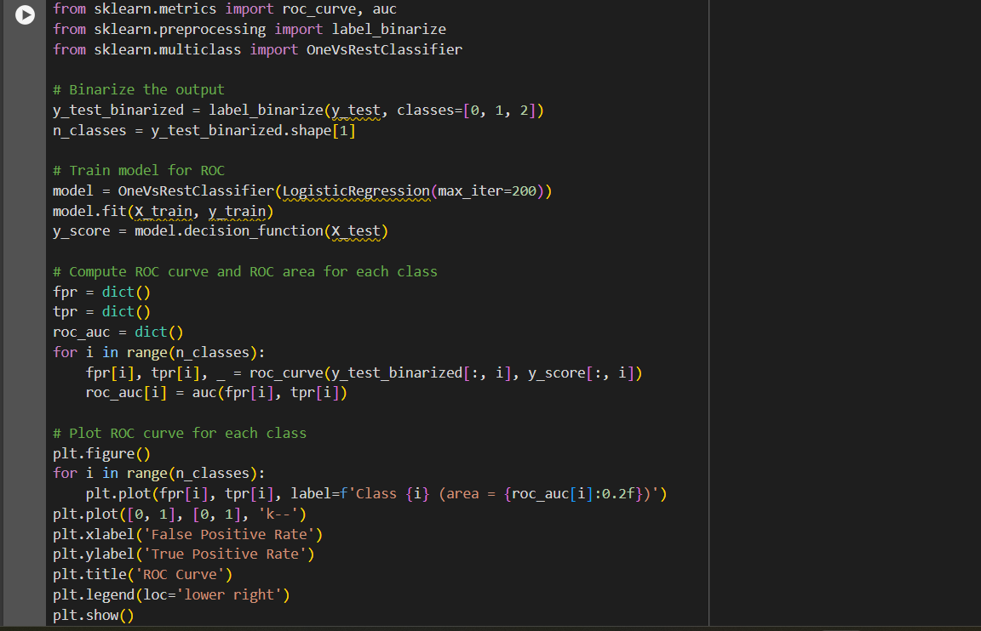

#### Question:

What does the ROC curve look like? What is the AUC value? How do these metrics help in evaluating your model's performance?

**Answer**: The ROC curve plots the true positive rate (recall) against the false positive rate for different threshold values. The AUC value quantifies the overall ability of the model to discriminate between classes. Higher AUC values indicate better performance. For a multi-class problem, the average AUC value can be reported.

### 4. Cross-Validation Reporting

#### Task:

Perform k-fold cross-validation (e.g., k=5) for your classification model and report the mean and standard deviation of the accuracy.

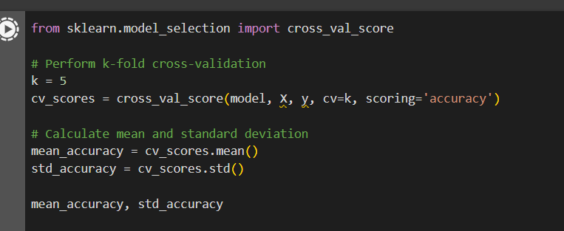

**Question:**

What are the mean and standard deviation of the cross-validation accuracy? Why is cross-validation important in model evaluation?

**Answer**: The mean and standard deviation of the cross-validation accuracy (example):

* Mean Accuracy: 0.96
* Standard Deviation: 0.02

Cross-validation is important because it provides a more reliable estimate of the model's performance by averaging results over multiple splits of the data, thus reducing the variance associated with a single train-test split.